Final Year Project (KIE4002)
Progress Report 1

Automated Surface-based Intraoperative Registration for Brain Tumor Resection Using Machine Learning Segmentation
by
Abdolroauf Rahmani
KIE170720
Supervisor :
Prof. Mahmoud Moghavvemi

Department of Electrical Engineering
Faculty of Engineering
University of Malaya
2020
Table of Contents
Problem Statement 3
Introduction (REFER TO THE GUIDE FOR MORE DETAILS) 4
General 5
Rigid (6 DOF) phase 5
Transform in registration 5
1) Linear 5
Registration Initialization 5
Similarity Metrics 5
Optimizer 5
Masking 5
Machine Learning algorithm types: 6
1) Supervised Learning 6
2) Unsupervised 7
3) Reinforcement 7
4) Other Algorithms 7
Image Segmentation Classifiers/Algorithms 11
1) Random forest: 11
2) Supported vector machine : 11
Image segmentation techniques 11
1) Multi-atlas segmentation (MAS) 11
Medical Profession 12
Segmentation 12
Feature Extraction 14
Visualization/rendering components 15
Frameworks 15
Files/Objects/Protocols 22
Motivation (Link Background to problem statement) 26
Research Methodology (Before this I need a problem and initial solution) 27
Reproducible Research 27
Translational Research 31
General Methodology for Development 31
Validation 32
Work Done So Far 32
3D Slicer and Registration 32
ICP Registration 36
Machine learning using 3D Slicer 36
Data sets 36
Next Semester Plans 37
References 37
Appendices 38
Notes 38
Proposal 40

Problem Statement
The first and the most important challenge in rigid body medical image registration is finding a good similarity measure. This measure should be maximized in order to achieve best alignment between two images. mutual information is one of the examples. The second challenge is the optimization method by which we want to find transformation function parameters. Most of the optimization methods converge to local maximums which is not desired.

Why is Medical Image segmentation important?
To improve registration by making it more accurate and faster. So what are the bottle necks for registration? To know this I need to first know the performance metrics and then factors affecting these metrics.
Performance metrics for a particular task:
Task: brain tumor localization
- Choice of similarity measure
- Choice of optimizer and the transformation
References:
- https://www.researchgate.net/post/What_are_major_challenges_in_medical_image_registration

Introduction (REFER TO THE GUIDE FOR MORE DETAILS)
Introduction – background of your research topic and give the problem statement.
General
- What is image registration?
  - Compare it to similar techniques like alignments
  - Highlight Transformation techniques for registrations
    - linear transform (with different techniques)

- What are different iterative methods used for image registration?
  - Go through the technical details of hows...
- What is the difference between standard registration and machine learning registration?
- What are different ML methods used for image registration?
  - Go through the technical details of hows…
    - What are RNN models?
    - What are CNN models?
    - What are Neural Networks?

- What devices/software/models/tools are used for image registration? Give example of applications
  - Name the models and explain the technical specifications (not a lot as this is general section)

Medical profession
- What is image registration in medical sector?
- What devices are used for image registration?
- Parameters considered when selecting a registration method?
- What instruments are used in surgeries? How to track them
- What data is rendered
- What components are used for visualization?
  - Software Package/Framework (3D Slicer)
  - Objects/files that store
  - NumpPy use for manipulation of Volume Nodes/data objects

General
Registration: Image registration is the procedure of lining up two (or more) images in the same geometrical coordinate system. The aim is to achieve the best spatial transformation that maps the structures-of-interest in the best way.

Rigid (6 DOF) phase
→ seen in day1_8_RegistrationTutorial

Transform in registration

Linear

translation only

rigid transform

similarity transform

Registration Initialization

Similarity Metrics
This process need to be carried out to obtain the optimum measure. Unusually this converges into local optima which is not desirable.

Optimizer

Masking

Machine Learning algorithm types:

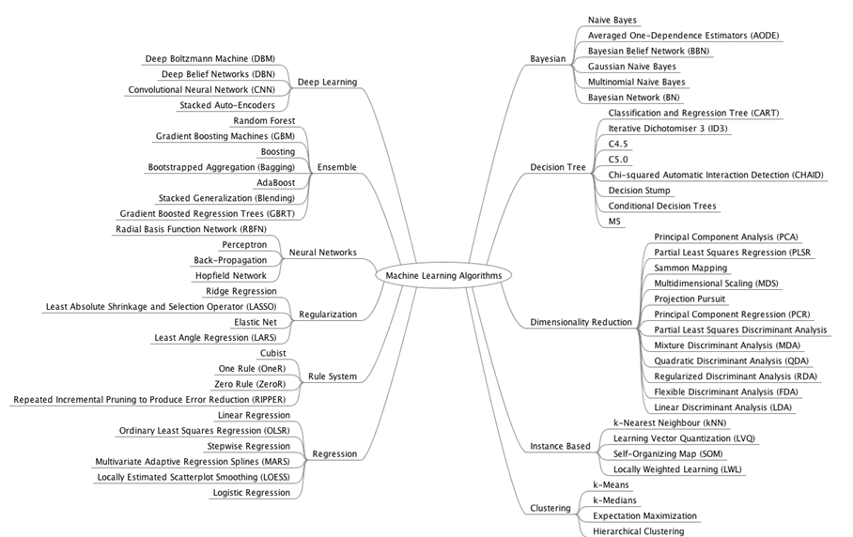
Supervised Learning
We have to predict a target or an outcome variable from a set of independent variables. Using these a function map is generated that maps inputs to the desired output. This process continues until this algorithm model produces the desired accuracy on data. Some examples of supervised learning are Decision tree, KNN, Regression, Logistic regression, etc.
I. Neural networks
A neural system forms an input vector to a subsequent yield vector through a model propelled by neurons and their network in the virtual mind. The model comprises of layers of neurons interconnected through loads that change the significance of specific inputs over others. Every neuron incorporates an activation work that decides the output of the neuron.

II. Decision trees
A Decision tree-like flowchart, where each inward hub signifies a test on a function, each branch speaks to a result of the test, and each leaf hub (terminal hub) holds a class mark. By parting the source set into subsets dependent on an attribute estimation test. This procedure is rehashed on each subset in a recursive way called recursive partitioning.

Unsupervised

In this, the input information isn’t marked and doesn’t have a known outcome. There is no outcome or target variable that needs prediction. For example, using it for the clustering population inside diverse population groups. This learning method is widely used for segmenting customers in such diverse groups for precise intervention. Some examples of unsupervised learning are K-means, Apriori, etc.

Reinforcement

In this sort of machine learning, ML operators try to locate the ideal method to achieve a specific objective. Improve execution on a particular assignment. As the operator makes a move that goes toward the objective, it gets a reward. It anticipates the best following stage to procure the most reward.
These are the most important of all other classifications in Machine learning. You’ll get an idea about what other models are currently in use in the fashion of its immense scope.
ML operators try to locate the ideal method to achieve a specific objective. Improve execution on a particular assignment. As the operator makes a move that goes toward the objective, it gets a reward. It anticipates the best following stage to procure the most reward.
These are the most important of all other classifications in Machine learning. You’ll get an idea about what other models are currently in use in the fashion of its immense scope.

Other Algorithms
- 1. Regression Algorithms
  - Ordinary Least Squares Regression (OLSR)
  - Linear Regression
  - Logistic Regression
  - Stepwise Regression
  - Multivariate Adaptive Regression Splines (MARS)
  - Locally Estimated Scatterplot Smoothing (LOESS)
- 2. Instance-based Algorithms
  - k-Nearest Neighbour (kNN)
  - Learning Vector Quantization (LVQ)
  - Self-Organizing Map (SOM)
  - Locally Weighted Learning (LWL)
- 3. Regularization Algorithms
  - Ridge Regression
  - Least Absolute Shrinkage and Selection Operator (LASSO)
  - Elastic Net
  - Least-Angle Regression (LARS)
- 4. Decision Tree Algorithms
  - Classification and Regression Tree (CART)
  - Iterative Dichotomiser 3 (ID3)
  - C4.5 and C5.0 (different versions of a powerful approach)
  - Chi-squared Automatic Interaction Detection (CHAID)
  - Decision Stump
  - M5
  - Conditional Decision Trees
- 5. Bayesian Algorithms
  - Naive Bayes
  - Gaussian Naive Bayes
  - Multinomial Naive Bayes
  - Averaged One-Dependence Estimators (AODE)
  - Bayesian Belief Network (BBN)
  - Bayesian Network (BN)
- 6. Clustering Algorithms
  - k-Means
  - k-Medians
  - Expectation Maximisation (EM)
  - Hierarchical Clustering
- 7. Association Rule Learning Algorithms
  - Apriori algorithm
  - Eclat algorithm
- 8. Artificial Neural Network Algorithms
  - Perceptron
  - Back-Propagation
  - Hopfield Network
  - Radial Basis Function Network (RBFN)
- 9. Deep Learning Algorithms
  - Deep Boltzmann Machine (DBM)
  - Deep Belief Networks (DBN)
  - Convolutional Neural Network (CNN)
  - Stacked Auto-Encoders
- Dimensionality Reduction Algorithms
  - Principal Component Analysis (PCA)
  - Principal Component Regression (PCR)
  - Partial Least Squares Regression (PLSR)
  - Sammon Mapping
  - Multidimensional Scaling (MDS)
  - Projection Pursuit
  - Linear Discriminant Analysis (LDA)
  - Mixture Discriminant Analysis (MDA)
  - Quadratic Discriminant Analysis (QDA)
  - Flexible Discriminant Analysis (FDA)
- Ensemble Algorithms
  - Boosting
  - Bootstrapped Aggregation (Bagging)
  - AdaBoost
  - Stacked Generalization (blending)
  - Gradient Boosting Machines (GBM)
  - Gradient Boosted Regression Trees (GBRT)
  - Random Forest
- Other Algorithms
  - Computational intelligence (evolutionary algorithms, etc.)
  - Computer Vision (CV)
  - Natural Language Processing (NLP)
  - Recommender Systems
  - Reinforcement Learning
  - Graphical Models

Image Segmentation Classifiers/Algorithms
Criteria of selection of classifier:
- well-researched
- sensitivity
- specificity : “A 20-fold increase of the number of unique training samples resulted, at best, in a 2% increase of specificity.”
- task specificity
- types of images required

Random forest:
Parameters:
- randomization
- added randomization
- number of tree count
- node size

Supported vector machine :
- Value of γ
- weight of margin terms

Image segmentation techniques

Multi-atlas segmentation (MAS)

Medical Profession

Segmentation
In medical profession it is an important step in classification of medical images to carryout preprocessing in form of segmentation or feature extraction. Such techniques will help to improve speed as well as accuracy of classification. Most similarity measures will have a lots of local optima around the global one; they lose their efficiency causing premature convergence or stagnation which are two prevalent confining dilemmas in the optimization field.
There are numerous diverse proposed segmentation techniques being used and researched on, but a common method for all application types is still unavailable. In general segmentation partitions images into different groups based on shared properties. Hence each group will have a homogeneous property. Common properties used for segmentation are color, intensity, texture and reactivity.
Common segmentation techniques are categorized based on time of abundant usage.
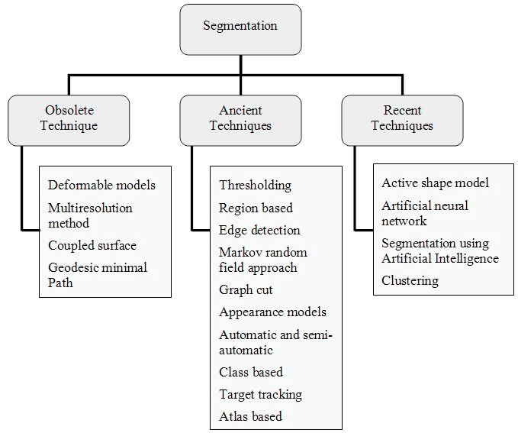
Obsolete segmentation techniques:
developed late 1990s and are mostly not in use.
- Deformable Models: They describe the boundaries of the objects by means of deformation curvatures or exteriors.
- Multiresolution Method:
- Coupled Surface:
- Geodesic Minimal Path:
Ancient segmentation techniques:
Ancient techniques are also old but are still in use in many applications.
- Thresholding:
The simplest but powerful technique available for image segmentation is thresholding. It is categorized into global and local thresholding. Global thresholding generally separate an image with one threshold whereas local threshold depends on the local characteristic of sub images. Selection of threshold has impotence in segmentation results and its selection is determined by operators’ visual assessment. Selection of threshold is generally based on histogram shape, optimization, class separation, spatial information by co-occurrence matrix, and posterior entropy. Details on various thresholding techniques can be found in the research papers.
- Markov Random Field Approach:
Markov random field is a pixel labelling probabilistic approach for image segmentation. This pixel labelling segmentation excerpt features from the contribution picture.
- Graph Cut
- Appearance Model:
- Automatic and Semi-automatic Segmentation:
- Class based Segmentation:
- Target Tracking:
- Atlas based Segmentation:
Recent segmentation techniques
These segmentation techniques are relatively new in medical imaging. Medical images have some uncertainties. To deal such uncertainties researchers started using intelligent techniques such as neural network, artificial intelligence, fuzzy set, Intuitionistic fuzzy set etc.
segmentation techniques that fall under this category:
- Active Shape Model:
Active shape models (ASM) were statistical prototypes of the shape of substances that iteratively distort to appropriate to an object in a new image. The shapes are forced through the point delivery prototypical. It is represented by a set of points that are controlled by the shape model. The active shape model algorithm aims to match the model to a new image.
- Segmentation using Artificial Intelligence:
- Clustering:

Feature Extraction
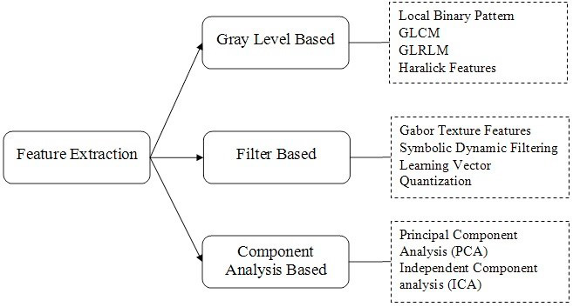

Visualization/rendering components

Frameworks

3D Slicer

Slicer Data Model
The Slicer Data Model is based on the Slicer Scene Data Structure. A Slicer scene is a collection of images, annotations, 3D models, spacial transforms, fiducials and cameras. Each element a scene is called a MRML node. The Medical Reality Markup Language (MRML) is an XML-based language used to serialize the content of Slicer scene on disk (scene.mrml). MRML is a data model developed to represent all data sets that may be used in medical software applications.
- MRML software library: An open-source software library implements MRML data in-memory representation, reading/writing files, visualization, processing framework, and GUI widgets for viewing and editing. The library is based on VTK toolkit, uses ITK for reading/writing some file format, and has a few additional optional dependencies, such as Qt for GUI widgets. The library kept fully independent from Slicer and so it can be used in any other medical applications, but Slicer is the only major application that uses it and therefore MRML library source code is maintained in Slicer’s source code repository.
- MRML file: When an MRML data is saved to file then an XML document is created (with .mrml file extension), which contains an index of all data sets and it may refer to other data files for bulk data storage. A variant of this file format is the MRML bundle file, which contains the .mrml file and all referenced data files in a single zip file (with .mrb extension).

MRML Scene
- All data is stored in a MRML scene, which contains a list of MRML nodes.
- Each MRML node has a unique ID in the scene, has a name, custom attributes (key:value pairs), and a number of additional properties to store information specific to its data type. Node types include image volume, surface mesh, point set, transformation, etc.
- Nodes can keep references (links) to each other.
- Nodes can invoke events when their contents or internal state change. Most common event is “Modified” event, which is invoked whenever the node content is changed. Other nodes, application logic objects, or user interface widgets may add observers, which are callback functions that are executed whenever the corresponding event is invoked.
Basic MRML Nodes
all objects in scene are stored in a hierarchical structure of MRML nodes. The basic types of nodes are as follows: (There are total of seven basic nodes)
- Data nodes: store basic properties of a data set. Data nodes are typically thin wrappers over VTK objects, such as vtkPolyData, vtkImageData, vtkTable. Volume and Model are two examples of data nodes.
- Display nodes: (vtkMRMLDisplayNode and its subclasses) specify properties how to display data nodes. For example, a model node’s color is stored in a display node associated with a model node.
- Storage Node: Describes how the data should be stored as file on disk. It can store one or more file name, compression options, coordinate system information, etc.
Notes:
Slicer Makes use of Toolkits below:
→ CTK: The Common Toolkit is a provides support code for medical image analysis, surgical navigation, and related projects.
→ VTK: Software system for 3D computer graphics, image processing and scientific visualization.
→ ITK: Application development framework used for the development of image segmentation and image registration programs
→ NumPy: is the fundamental package for scienCfic compuCng with Python.
→ PythonQT: is a Python binding for Qt.
→ Qt: is a cross-platform framework used as a graphical toolkit.

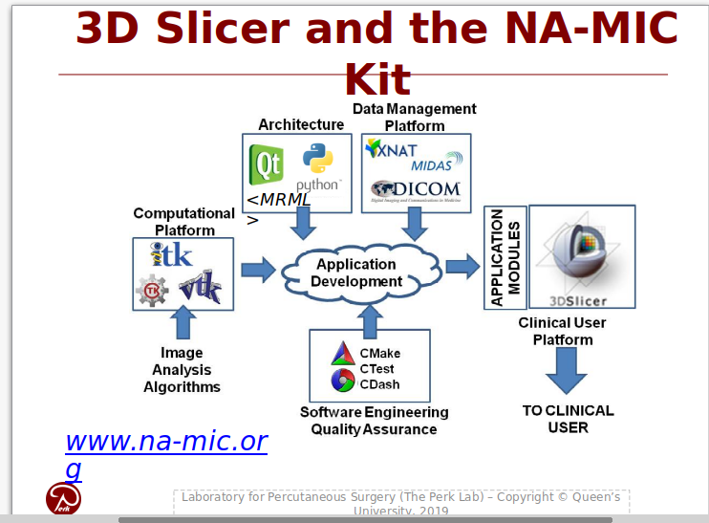Figure 1: 3D Slicer along with NA-MIC kit provides an all in one development platform for medical image processing projects. https://www.na-mic.org/wiki/NA-MIC-Kit
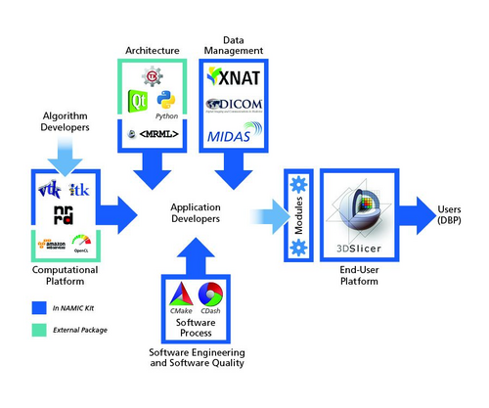
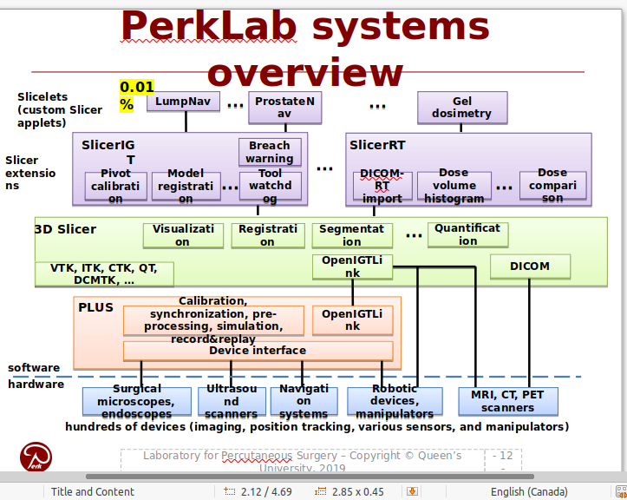Figure 2: 3D Slicer example use for registration and segmentation in Perklabs

References and Additional information
- https://slicer.readthedocs.io/en/latest/developer_guide/mrml_overview.html
- https://www.slicer.org/wiki/Documentation/4.1/Developers/MRML#MRML_Nodes
- https://www.slicer.org/wiki/Documentation/Nightly/ScriptRepository
- Commercial use of 3D slicer-case studies
  - Gel Dosimetry
  - Lump Nav

Files/Objects/Protocols

PCD and other 3d file formats for point clouds
http://pointclouds.org/documentation/tutorials/pcd_file_format.html#:~:text=Each%20PCD%20file%20contains%20a,using%20new%20lines%20(%5Cn)

DICOM
Digital Imaging and Communications in Medicine (DICOM) is the standard for the communication and management of medical imaging information and related data. DICOM is most commonly used for storing and transmitting medical images enabling the integration of medical imaging devices such as scanners, servers, workstations, printers, network hardware, and picture archiving and communication systems (PACS) from multiple manufacturers.
DICOM files can be exchanged between two entities that are capable of receiving image and patient data in DICOM format. The different devices come with DICOM Conformance Statements which state which DICOM classes they support.
The standard includes a file format definition and a network communications protocol that uses TCP/IP to communicate between systems.
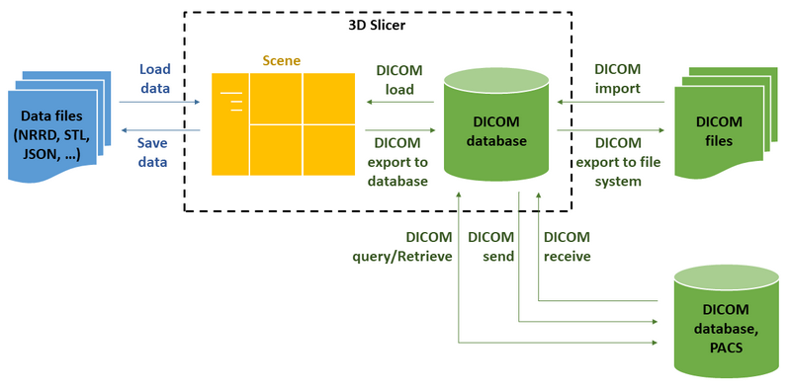Figure 3: Use of DICOM in 3D slicer which is software package for image analysis and scientific visualization.
DICOM file format organizes data following the hierarchy of
- Patient … can have 1 or more
- Study (single imaging exam encounter) … can have 1 or more
- Series (single image acquisition, most often corresponding to a single image volume) … can have 1 or more
- Instance (most often, each Series will contain multiple Instances, with each Instance corresponding to a single slice of the image)
As a result of imaging exam, imaging equipment generates DICOM files, where each file corresponds to one Instance, and is tagged with the information that allows to determine the Series, Study and Patient information to put it into the proper location in the hierarchy.

There is a variety of DICOM data objects defined by the standard. Most common object types are those that store the image volumes produced by the CT and MR scanners. Those objects most often will have multiple files (instances) for each series. Image processing tasks most often are concerned with analyzing the whole image volume, which most often corresponds to a single Series.
References and more information:
- The DICOM Homepage: http://dicom.nema.org/
- DICOM on wikipedia: http://en.wikipedia.org/wiki/DICOM
- Clean and simple DICOM tag browser: http://dicom.innolitics.com
- A useful tag lookup site: http://dicomlookup.com/

General Registration Module in 3D Slicer
What does the registration module do?
We selected different “LookUp Table” and then selected the transformation method properties.
- We then use linear transform as output given one of the objects is fixed.
- Rigi 6 DOF (Six degrees of freedom (6DoF)) is selected

What are the other registration techniques?
- BSpline Transform
- Registration phases:
  - Rigid+scale (7DOF)
  - Rigid + scale+Skew(10DOF)
  - Affin (12DOF)
  - BSpline (>27DOF)
  - SyN
  - Composite (many DOF)

What is initialization Transform?
I selcted inititalization transform as the saved linear transformation

Motivation (Link Background to problem statement)
Defining new problems, new constraints, new opportunities, new approaches
Motivation – why is it important to solve this problem? Any existing solutions? The pros and cons of these solutions. Why need further work?
Objective(s) – what do you want to achieve in your project?

Research Methodology (Before this I need a problem and initial solution)
Research Methodology – how and what to do to achieve your objective(s)?
Your work done so far in the first semester (in detail) – report only your original work and results, not results from other papers. (Results and discussion)

By end of this semester I should be finished till “Initial Solutions” and have a strong background on the method the initial method uses to achieve a given objective. The iterative part of FYP will be done next sem.
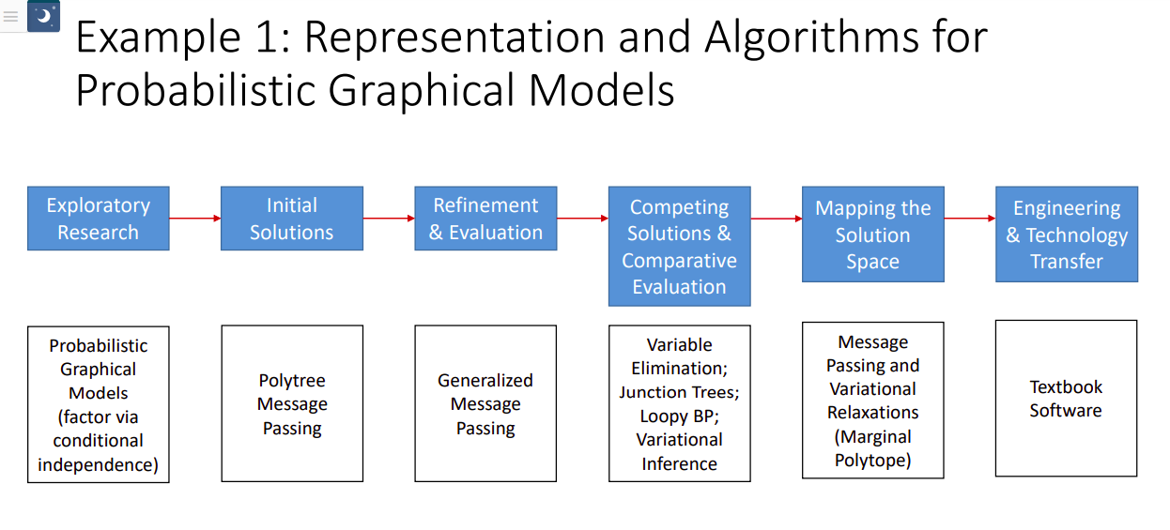

Reproducible Research
Scientific method: propose hypothesis, prove it by experiments. Here instead of hypothesis we have a design which is to solve an established problem.
First Problem is established, which is done by first evaluating purposes of ML in registration and then the gaps in the solutions already existing. The problem will focus to solve a gap.
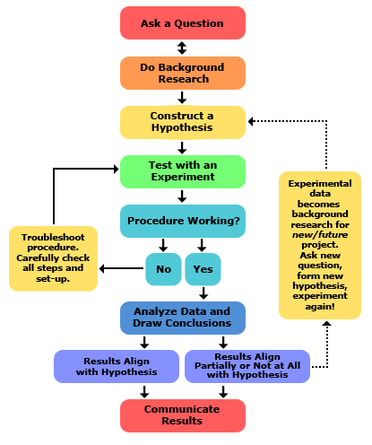
Scientific computation is becoming a core component of modern scientific inquiry. In the June 1996 issue of the flagship Journal of the American Statistical Association nine of twenty articles were computational, while in the June 2006 issue 33 of 35 were, and this trend is not limited to statistics. In numerous fields the increasing prevalence of data collection, computerized simulations, and deep data exploration indicate that scientific computation is becoming central to the scientific method.

Computational research is widely varied but components of the research that are necessary for others to understand and replicate the research, known as compendium, remain the same. They are:
- The Research Paper.
  - If included in a compiled format, such as pdf, then include the source files (TeX, Word, or WordPerfect files for example).
- The Data:
  - The data itself.
  - Documentation completely describing the data so that a researcher in the same field could make use of it: Sources, components, and possibly interpretation.
  - A description of how the data was brought into the form used in the research, including any selection and arrangement of the data, cleaning methods, or processing of variables in preparation for analysis.
  - The code and instructions used to bring the data into the form used in the research.
  - Documentation of any code used in this process.
- The Experiment:
  - The code and instructions used in the experiment, including all source code.
  - Documentation of any code used, including pseudocode and algorithm descriptions.
  - A clear listing of the parameters, settings, and conditions under which the code was used to achieve the results described in the paper, including software, platform, and computing environment.
  - A clear description of the experimental methodology.
References
- Stodden, Victoria: Enabling reproducible research: Open licensing for scientific innovation , International Journal of Communications Law and Policy, Forthcoming , 2009

Translational Research
Translational research – a term often used interchangeably with translational medicine or translational science or bench to bedside – is an effort to build on basic scientific research to create new therapies,[1] medical procedures, or diagnostics. Basic biomedical research is based on studies of disease processes using, for example, cell cultures or animal models.[2] The adjective "translational" refers to the "translation" (the term derives from the Latin for "carrying over") of basic scientific findings in a laboratory setting into potential treatments for disease.
References
- https://en.wikipedia.org/wiki/Translational_research

General Methodology for Development
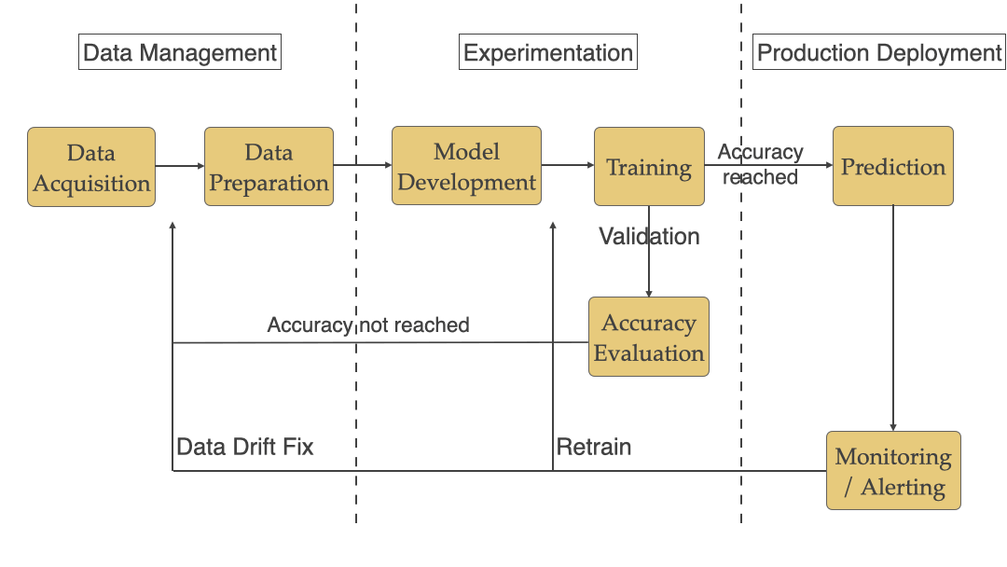
What does a user expect ?
- Easy install and upgrade
- “Standard” clinical behavior
- Advanced functionality
- Consistent interface

Validation
Fidelity levels: Simulated < Synthetic phantoms < Animal tissue (butcher shop) < Cadaver < Patient
For validation we will do with simulations and synthetic phantoms.

Work Done So Far
- Using 3D Slicer for 2D image registration
- Using 3D slicer for ICP
- Select a ML model and do initial solutions
- skin segmentation

3D Slicer and Registration
- Manual: translation, rotation in 3D
- Automatic: rigid, deformable, with various similarity metrics, initialization methods, optimizers, masking, etc.

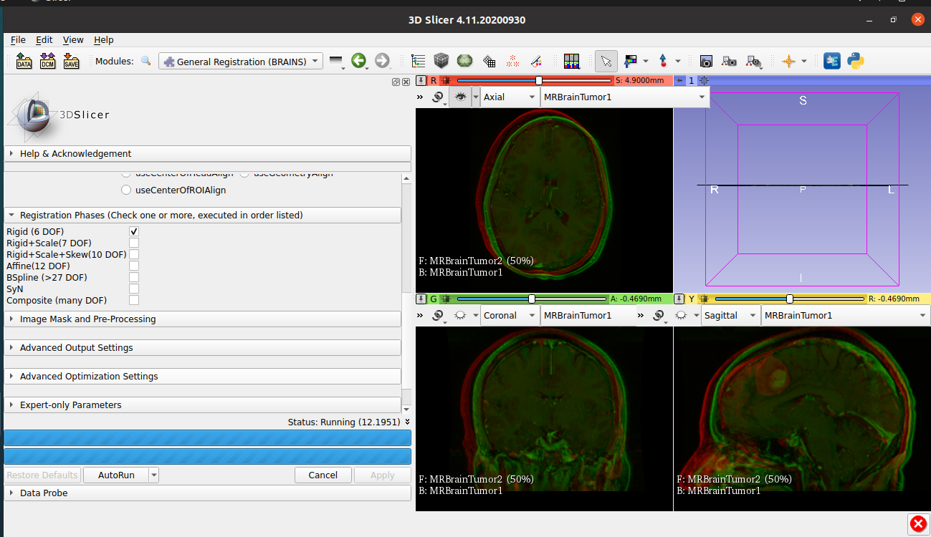Figure 4: 2 MRI objects shown 3D Slicer, and they are yet to be aligned
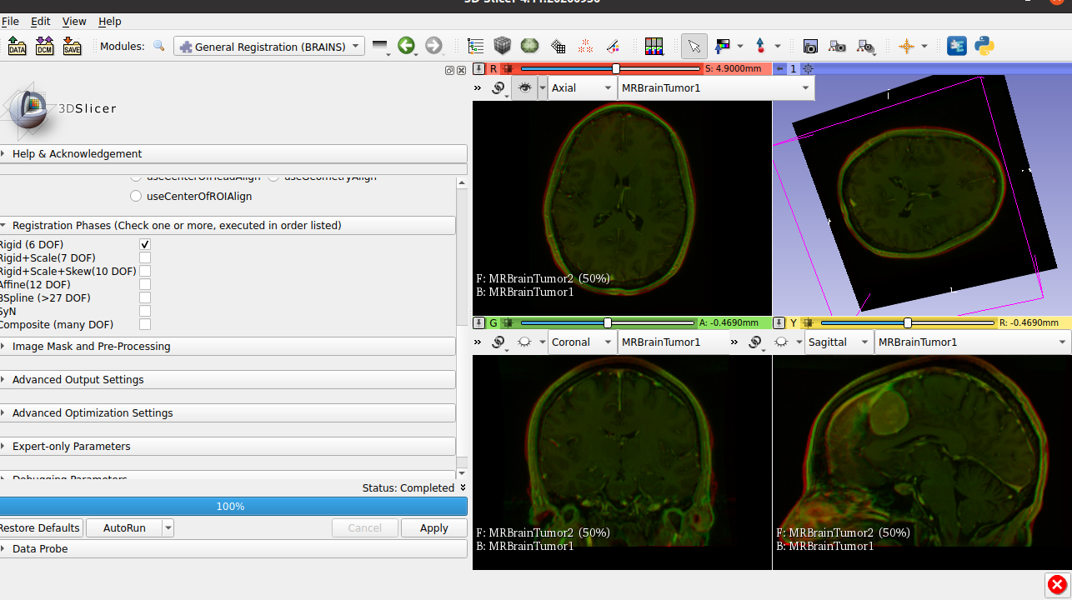Figure 5: Rigid Registration using linear transform with 6DOF
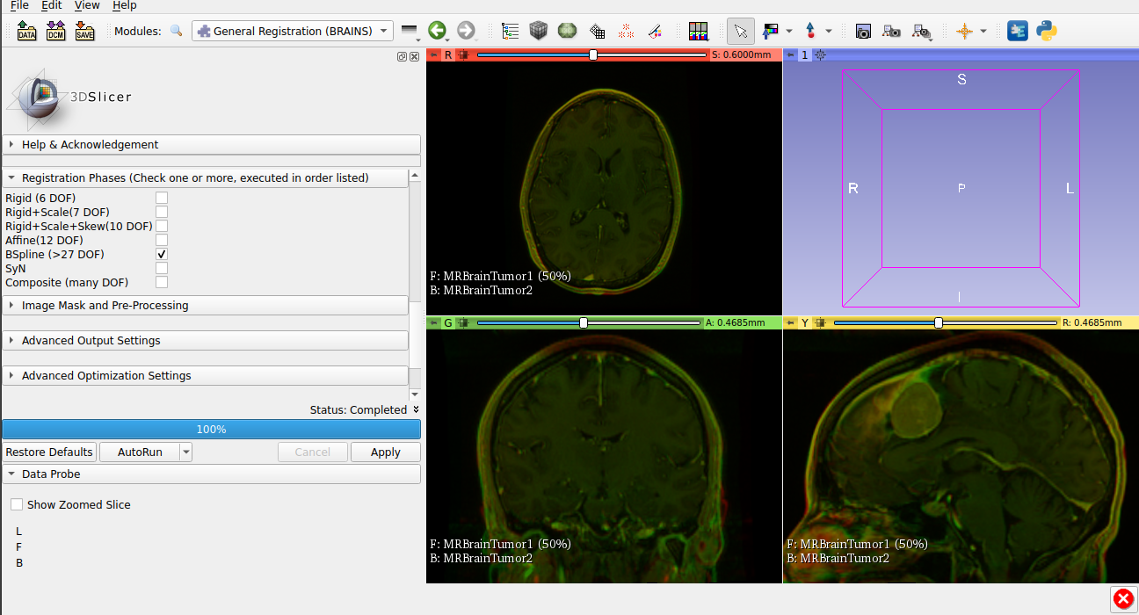Figure 6: Deformable registration using BSpline with >27 DOF and using the result of linear transformation as initialization.

Fiducial registration workflow in 3D Slicer follows the below steps:
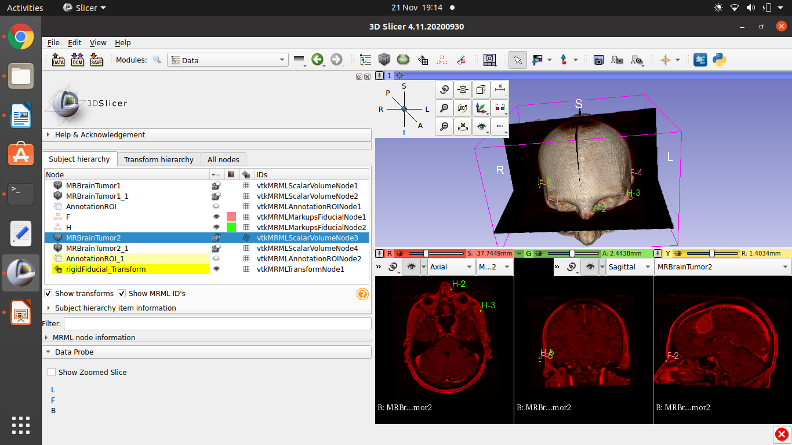Figure 7: Fiducial Registration was carried out using 3D Slicer. Based on the fiducial locations a transform was made and was applied on the volume object
- Providing information about the volume objects in form of point coordinates of unique features (nose bridge, corner of eye, and ear edge). Coordinates of same features in the other volume is determined as well.
- Using the the two list of fiducial locations a linear transform function was created for a rigid transform.
- This function was applied on the mobile volume to register it.
This module computs a linear transform from two lists of fiducials. The transform can either be translation only, rigid transform, or similarity transform.

References:
- https://www.slicer.org/wiki/Slicer3:Registration Contains the algorithm behind registrations carried out

ICP Registration

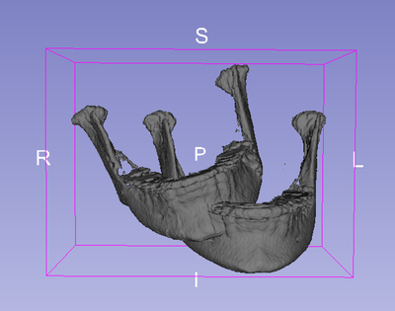
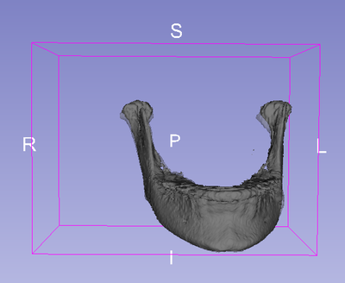
- https://discourse.slicer.org/t/details-on-icp-registration-implementation/3343
- https://www.slicer.org/w/index.php/Documentation/4.4/Extensions/CMFreg
- https://www.slicer.org/wiki/Documentation/4.4/Modules/SurfaceRegistration
- https://sites.google.com/a/umich.edu/dentistry-image-computing/e-learning/Videos-Tutorials?authuser=0
- https://slicer.kitware.com/midas3/folder/1555 Data store to get data

Machine learning using 3D Slicer
References
- http://www.deepinfer.org/pages/install/usage_guide/
- https://www.slicer.org/wiki/Documentation/Nightly/Modules/DeepInfer
- https://discourse.slicer.org/t/machine-learning-model-importing/6298/4

Skin segmentation using 3d Slicer
https://lassoan.github.io/SlicerSegmentationRecipes/SkinSurface2/

Segment registration
https://github.com/SlicerRt/SegmentRegistration
https://github.com/SlicerIGT/SlicerIGT contains a lot of tutorials and there is section for model registration. SegReg is under this.
http://www.slicerigt.org/wp/

Tutorials for 3DSlicer
https://lassoan.github.io/SlicerSegmentationRecipes/ You can find basic workflows for segmentation of certain anatomies such as skin.

Landmark detection
Using 2D data:

Using 3D

Data sets
- https://www.insight-journal.org/rire/download.php

Next Semester Plans
Planning for the second semester (Gantt Chart)

References
References: include only relevant references, from reliable sources

Appendices

Notes
Deform-able registration doesn't run as my computer doesn't have enough resources.
Debug codes
General Registration (BRAINS) standard output:

Original Fixed image origin[-119.531, -119.531, -77.7, 0]
Read ITK transform from file: /tmp/Slicer-raouf/HEGBI_vtkMRMLLinearTransformNodeE.h5
HACK: 0 AffineTransform
TransformTypes: BSpline(1 of 1).

=============================== ITKv4 Registration: Starting Transform Estimations for BSpline(1 of 1).===============================

Initialized BSpline transform is set to be an identity transform.
- Number of parameters = 9945
-- WARNING: Only one in every 663 parameters is printed on screen.

LBFGSB optimizer is used for BSpline registration using following parameters set:
-----------------------------------------------------------------------------------
NOTICE: You can use commandline options to adjust these parameters to find a
probable better compromise between running time and registration precision.
-----------------------------------------------------------------------------------
- Cost Function Convergence Factor : 2e+13
- Projected Gradient Tolerance : 1e-05
- Maximum Number of Corrections : 25
- Maximum Number of Evaluations : 900
- Maximum Number of Iterations : 1500

Moving image is warped by initial transform, before it is passed to the BSpline registration.

*** Running bspline registration (meshSizeAtBaseLevel = [14, 10, 12]) ***

LBFGSB optimizer does not support scaling. All scales are set to one.

General Registration (BRAINS) terminated with an unknown exception.

vtkMRMLScene::Clear

Proposal

Supervisor | Mahmoud Moghavvemi
Title | Automated Facial Landmark Detection in medical images for patient-image registration in Cranial Surgeries
Synopsis (Background, Problem statement, Objectives) | Background  Automating medical workflows is essential in saving time and reducing human error. Registration is a process of alignment and transformation of two images of the same subject. For instance registration of two images of the same part of the body is carried out to determine the correspondence between them. Registration is specially important for surgeries as it would help to make minimal incisions and reduce operation time. Currently the registration process is made up of manual steps which makes registration inefficient.  Problem Statement  One way for craniofacial registration is to automatically detect facial landmarks. Automating facial landmark detection is essential part of automatic registration workflow. However most facial landmark detectors are not meant for the special characteristics of medical images.  Objectives  - Compare neural network based landmark detection over traditional methods.  - Evaluate a technique for segmentation of face from the rest of head model.  - obtain reliable model for facial landmark detection of medical images
Expected Outcomes | - Automatic Segmentation method to obtain face from the model.  - Automatic facial landmark detector for medical images.  - Determine the viability of developed algorithms for cranial surgery
Equipment Needed | Personal computer, suitable programming language software (3D slicer-free)

Complex Engineering Attributes
Assigned PLOs: PLO3 (WK5), PLO4 (WK8), PLO5 (WK6), PLO7 (WK7), PLO9, PLO11, PLO12

Attribute | Complex Engineering Problems have characteristic WP1 and some or all of WP2 to WP7: | PLOs addressed? | Comments from  FYP supervisor  (give examples / clarifications )
Depth of Knowledge  Required | WP1: Cannot be resolved without in-depth engineering knowledge at the level of one or more of WK3, WK4, WK5, WK6 or WK8 which allows a fundamentals-based, first  principles analytical approach | PLO3, PLO4, PLO5, PLO7 | Required the fundamental knowledge on various field of image processing and artificial intelligence, such as template matching, image enhancement and filtering as well as machine learning. Student needs to basically apply fundamental knowledge in image processing and artificial intelligence to solve a given design problem.
Range of conflicting  requirements | WP2: Involve wide-ranging or conflicting technical, engineering and other issues | PLO3, PLO4 | During the design process, student needs to demonstrate limitations that they encounter during the process, e.g. lighting, image size and acquisition distance.
Depth of analysis  required | WP3: Have no obvious solution and require abstract thinking, originality in analysis to formulate suitable models | PLO7 | Student need to understand the problem and apply suitable solution which may have been applied in similar problem but in different application
Familiarity of issues | WP4: Involve infrequently encountered issues | PLO5 | The problem is unique thus requires  innovative thinking and adoption of many existing designs which are not directly applicable to the given problem
Extent of applicable  codes | WP5: Are outside problems encompassed by standards and codes of practice for professional engineering |  | Need to understand the strict medical imaging standards which can be encompassed for other sectors that use CV (e.g AV).
Extent of stakeholder  involvement and  conflicting requirements | WP6: Involve diverse groups of  stakeholders with widely varying needs |  | Many types of surgery and workflows associated with cranial surgery, which results in wide range of requirements
Interdependence | WP 7: Are high level problems including many component parts or sub-problems |  | Includes software with sub problems within them.

